CSCI 5380

Network Virtualization and Orchestration

Lab 7

End-Host Container Networking

University of Colorado Boulder

Department of Computer Science

Network Engineering

Professor Levi Perigo, Ph.D.

# Objective 1 – Network Function-Enabled End Host

# Summary:

Network infrastructure operation and management are becoming increasingly complex. This complexity is a result of multi-vendor devices, distributed platforms, and the numerous protocols for control and management present in the network (Figure 1).

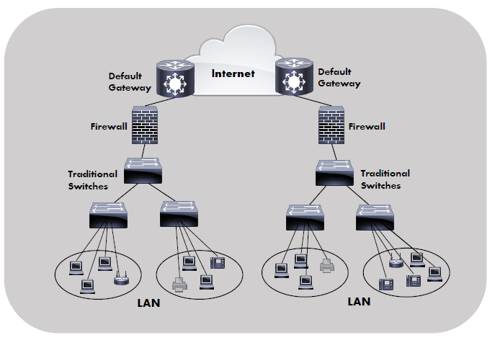

Figure 1: Traditional Network Diagram

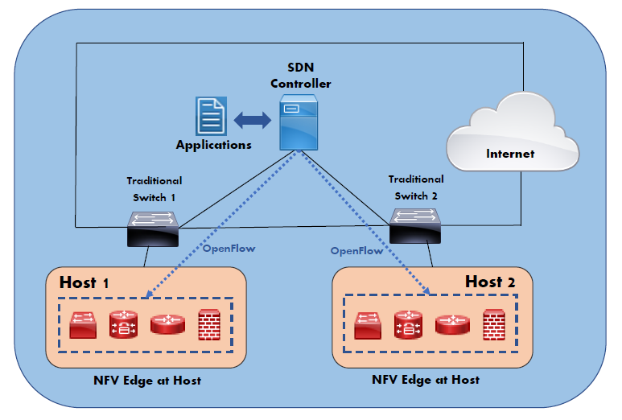

Figure 2: Next Generation Network Diagram

Previous studies indicate that shifting network functions from the core network infrastructure to the end hosts offers network benefits and reduces the dependencies on the core infrastructure (Figure 2). In this lab, you will develop a novel framework to enable network functions on end hosts by utilizing container virtualization technologies. The lightweight and flexible nature of containers facilitates simple deployment and management while enabling application-specific intelligence to reside on the end host relieving the core network infrastructure of these complexities. To achieve this, you will implement software-defined networking (SDN) concepts and technologies to enable centralized control of end host network functions.

# Deliverables:

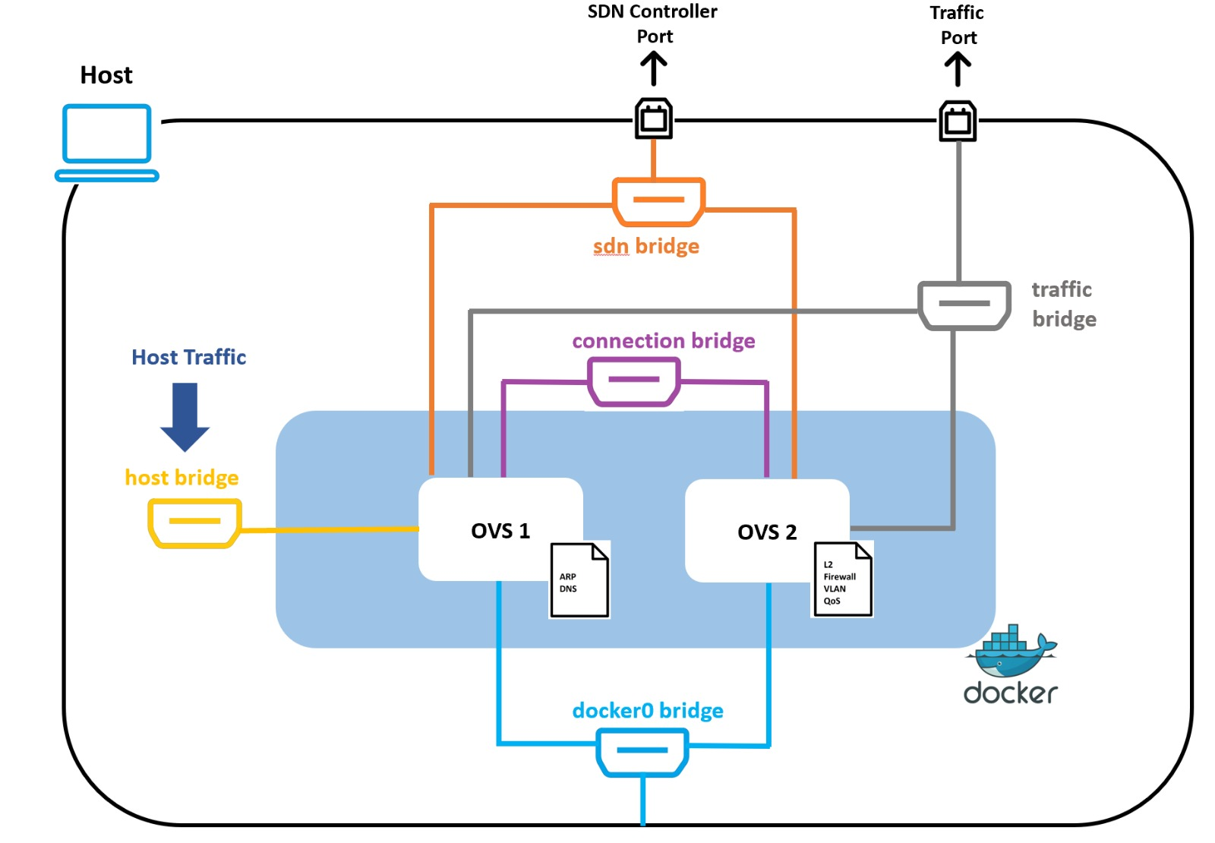

Figure 3: Lab Design (Objective 1 & Objective 2)

1. Implement an OvS Container on the host.
2. Force all traffic (ingress/egress) from/to the host to traverse the OvS Container.
3. Control the OvS Container with an SDN controller (Traditional or via API).
   1. Create a novel application that manipulates the container. Demonstrate the functionality and indicate your application is applied and effecting the traffic flow to/from the host via the container.

# Objective 2 – (*Extra Credit*) Network Function-Enabled End Host – Service Chaining (Multiple-Flow Tables)

# Summary:

This lab objective aims at simplifying the SDN architecture by deploying network functionalities in the form of standalone VNFs such as firewall, routing, QoS, load-balancing, and DNS as multiple flow-table entries on the Open vSwitches installed on the host devices such as laptops and servers using Docker containers (Figure 3). The creation of multiple service chains using different VNFs helped achieve seamless network operability and performance. The containers have access to the kernel and operate on a single instance, which reduces the kernel overhead and enhances performance as compared to Virtual Machines (VMs). The deployment of VNFs on the host reduces latency, improves throughput, provides enhanced QoS, faster service delivery, easier adoption of DevOps practices, and improved backward compatibility. This solution increases scalability, reduces network complexity, and enhances flexibility at a reduced cost by leveraging compute resources available on the hosts. As a result, this solution reduces the risk of a single point of failure, which was prevalent in the traditional network. For example, failure of a network firewall in the traditional network impacts all the network devices, whereas the failure of a network firewall impacts only a single host.

# Deliverables:

1. Implement an OvS Container on the host.
2. Force all traffic (ingress/egress) from/to the host to traverse the OvS Container.
3. Control the OvS Container with an SDN controller (Traditional or via API).
   1. Create a novel application that manipulates the container, and provides different “network functions” through multiple flow tables on the container (i.e. firewall is flow table 2; QoS is flow table 3). Demonstrate the functionality and indicate your application is applied and effecting the traffic flow to/from the host via multiple flow tables on the container.

# Objective 3 – (*Extra Credit*) Network Function-Enabled End Host – Service Chaining (Multiple VNFs)

# Summary:

This lab objective aims to implement NFEH service chaining through multiple VNFs (containers) on the edge (instead of via a single container with multiple flow tables). See Figure 4.

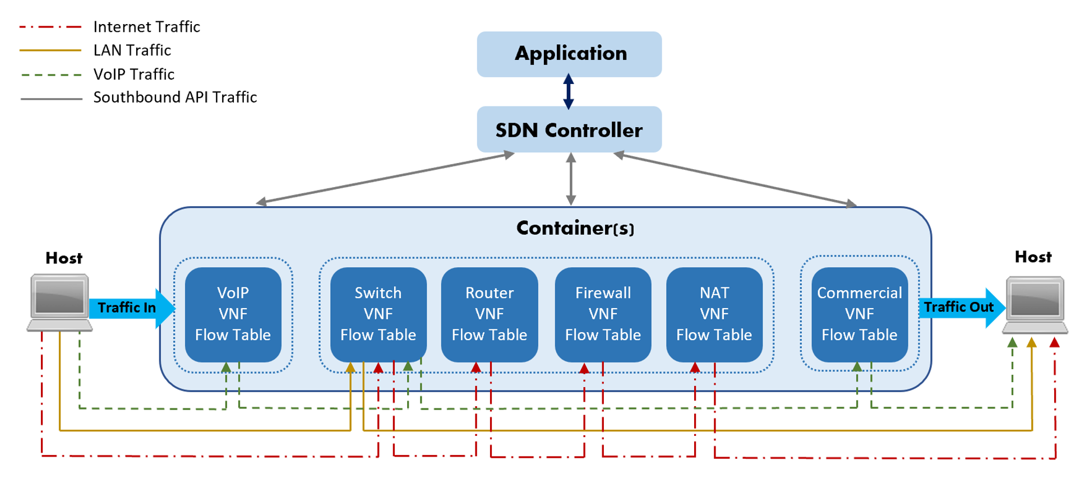

Figure 4: Service Chaining via VNFs

# Deliverables:

1. Implement multiple OvS Containers on the host.
2. Force all traffic (ingress/egress) from/to the host to traverse the OvS Containers chains.
3. Control the OvS Containers with an SDN controller (Traditional or via API).
   1. Create a novel application that manipulates the containers, and provides different “network functions” through multiple containers (i.e. firewall is container 1; QoS container 2). Demonstrate the functionality and indicate your application is applied and effecting the traffic flow to/from the host via multiple containers.